A MINI PROJECT REPORT ON

“SOLAR SYSTEM”
SUBMITTED TO THE SAVITRIBAI PHULE PUNE UNIVERSITY, PUNE IN THE PARTIAL FULFILLMENT OF THE REQUIREMENTS FOR THE AWARD OF THE DEGREE
OF
Computer Engineering.
SUBMITTED BY
(DIVISION – SE-B, BATCH – S2)
Om Jangam
UNDER THE GUIDENCE OF
Ms. Manjiree Otari



COMPUTER ENGINEERING

P.E.S MODERN COLLEGE OF ENGINEERING PUNE - 411005.

SAVITRIBAI PHULE PUNE UNIVERSITY

[2024 - 25]

Progressive Education Society’s Modern College of Engineering Shivajinagar, Pune - 411005.

CERTIFICATE

This is to certify that the following students of Computer Engineering of PES’s, Modern College of Engineering have successfully completed their mini project and design of project entitled “Solar System” under the guidance of the course instructor.

The Group Members are:

Sr No. | Group Members | Roll Number
 | Om Jangam | 29021

This is in partial fulfillment of the award of the degree Computer Engineering of Savitribai Phule Pune University.

Date:

Ms. Manjiree Otari Dr. S. A. Itkar
Course Instructor H.O.D.
. Dept. of Computer Engineering

Acknowledgement

It gives us pleasure in presenting the partial project report on ‘Solar System’.
Firstly, i would like to express our indebtedness appreciation to our course instructor. Her constant guidance and advice played very important role in making the execution of the re- port. She always gave us her suggestions that were crucial in making this report as flawless as possible.
We would like to express our gratitude towards Dr. S. A. Itkar Head of Department of Computer Engineering Department, PES Modern College of Engineering for kind co-operation and encouragement which helped us during the completion of this report.
Also we wish to thank our Principal, Prof. Dr. Mrs. K. R. Joshi and all faculty members for their whole hearted co-operation for completion of this report. We also thank our laboratory assistants for their valuable help in laboratory.
Last but not the least, the backbone of our success and confidence lies solely on blessings of dear parents and lovely friends.

Sr No. | Group Members | Roll Number
1) | Om Jangam | 29021

Index

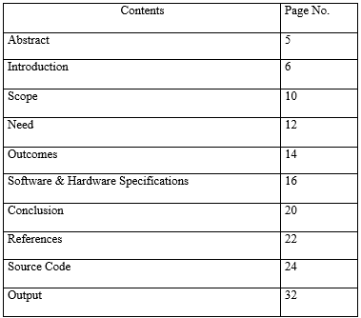
Abstract
The project "Solar System" aims to develop an interactive 3D simulation of the Solar System using OpenGL and auxiliary libraries like GLEW, GLUT/GLFW, and GLM.
The goal is to provide a realistic and educational visualization of planetary orbits, rotations, and scaling within the Solar System.
The simulation models the Sun, planets, and their moons, representing their relative sizes, positions, and motion patterns. Each celestial body follows an orbital path around the Sun, and planets rotate on their axes with realistic tilt angles and speeds.
Using OpenGL's rendering capabilities, planets are shaded and textured to enhance visual realism, with lighting effects simulating the Sun’s illumination. Key libraries play significant roles: GLEW helps manage OpenGL extensions across platforms, GLUT/GLFW assists with window management and input handling, and GLM is utilized for 3D transformations, vector, and matrix operations.
This project provides interactive features, allowing users to zoom in on specific planets, change viewing angles, and toggle various display options for educational purposes. The simulation serves as a dynamic tool for learning planetary science and demonstrating OpenGL’s capacity for real-time graphics rendering.
Key features of the project include:
- Realistic Modeling of Celestial Bodies: Each planet and moon is modeled with textures and scaling to reflect its unique appearance and relative size within the Solar System, creating a lifelike view. The Sun is given emissive lighting to simulate illumination, casting realistic shading and light reflection across nearby bodies.
- Orbital Mechanics and Rotational Dynamics: The simulation incorporates real-world orbital characteristics such as elliptical paths, varying orbital speeds (based on Kepler’s laws), and axial rotations. Each planet orbits the Sun at an accurate speed and inclination, and rotation rates around their own axes are included to match day lengths.
- Lighting and Shading: OpenGL lighting models are applied to simulate sunlight and shadow effects across planets, improving depth perception and visual realism. The Sun serves as a light source, dynamically illuminating planets as they move along their orbits.
- Interactivity and User Controls: Users can interact with the simulation to view celestial bodies from different perspectives, zoom in on specific planets or moons, and pause or resume orbital motion. Keyboard and mouse controls allow easy navigation, providing an immersive experience for users exploring the Solar System.

1.
Introduction

1.1 Introduction
The purpose of this project is to develop a three-dimensional interactive simulation of the Solar System using OpenGL. The simulation is intended to mimic the orbits, rotations, and relative sizes of the planets and moons around the Sun. By leveraging OpenGL and auxiliary libraries like GLEW, GLFW, and GLM, the project provides an immersive educational tool that allows users to visualize and understand planetary motion and astronomical phenomena. The simulation emphasizes both realism and user interactivity, offering a simplified yet accurate view of the Solar System.

1. Purpose and Vision

The purpose of this Solar System simulation project is to create an interactive, educational tool that makes learning about planetary orbits, rotations, and sizes accessible and engaging. Using OpenGL’s 3D capabilities, the simulation provides a realistic visualization of celestial dynamics, allowing students, educators, and enthusiasts to explore and understand the Solar System in an immersive way.
The vision is to expand this simulation into a comprehensive platform featuring additional phenomena like asteroid belts, comets, and spacecraft paths. Designed for use in educational settings and by space enthusiasts, the project aims to support dynamic, customizable exploration of the Solar System, integrating real-time data and new scientific discoveries as it evolves.

2. Core Features and User Flow

Core
• 3D Model of the Solar System: Realistic, textured models of the Sun, planets, and moons with accurate relative sizes, colors, and positions.
• Orbital and Rotational Dynamics: Each planet follows a true-to-scale orbit around the Sun and rotates on its axis, mimicking real-world motions with variable speeds.
• Lighting and Shading: The Sun acts as a light source, casting dynamic shadows and light reflections on nearby celestial bodies to enhance realism.
• User Interactivity:
- Camera Controls: Users can zoom, pan, and rotate around the Solar System for a better view.
- Planetary Focus: Allows users to zoom in on specific planets or moons and view detailed textures and rotation.
- Simulation Speed: Adjustable simulation speed, enabling users to see the Solar System's motion at different time scales.
• Display Options: Toggle options to display or hide orbital paths, planet labels, and speeds.

User Flow
- Start Screen: Users begin at a main menu with options to start the simulation, access controls, or view educational information.
- Exploration Mode: Once in the simulation, users can interact with the Solar System in "free roam" mode, using camera controls to zoom and rotate around the scene.
- Planetary Focus: Clicking on a specific planet brings it into focus, providing detailed views and planetary information.
- Toggle Controls: Users can adjust options like orbital paths, labels, and speed via an on-screen menu.
- Educational Panels: Interactive panels provide real-time information about selected planets or the overall Solar System.
- Exit/End: Users can exit the simulation or return to the main menu for additional resources or controls.

3. Architecture and Design
The architecture of this Solar System simulation is designed with modularity and performance in mind, allowing for easy scalability, efficient rendering, and interactive functionality. The system is built in C++ and relies on OpenGL for graphics rendering, with libraries such as GLEW for extension management, GLFW for window and input handling, and GLM for mathematical transformations. The architecture is divided into several core modules to handle different aspects of the simulation:

1. System Architecture
- Rendering Engine
  - OpenGL Renderer: Responsible for managing the rendering pipeline, handling textures, lighting, shading, and updating frames.
  - Shader Management: Uses GLSL shaders to handle lighting calculations, shadows, and textures, creating a realistic visual effect for each celestial body.
  - Model Loader: Loads 3D models and textures for planets, moons, and the Sun, applying transformations to represent size, position, and rotation.
- Scene Manager
  - Celestial Object Module: Each celestial body (Sun, planets, moons) is represented as an object with properties like size, texture, orbit, and rotation speed.
  - Orbit and Rotation System: Manages each object's orbital path and axial rotation based on real-world astronomical data, updating positions at each frame.
  - Lighting and Shadowing: The Sun acts as a dynamic light source, casting shadows and adjusting light intensity across planets and moons based on their distance and position.
- Input and Interaction
  - Camera Control: Supports zoom, pan, and rotation around the Solar System, allowing users to navigate and explore freely.
  - User Interface (UI): On-screen UI panels provide toggles for display options (e.g., orbit paths, planet labels) and simulation controls like speed adjustments.
  - Event Handler: Detects user input, managing actions like selecting specific planets, toggling simulation speed, and accessing information panels.
- Physics and Animation
  - Time Control Module: Manages the simulation speed, enabling users to observe the Solar System’s motion in accelerated or slowed-down time.
  - Orbit Calculation: Calculates each planet's orbit using predefined elliptical paths, and updates the position of celestial objects frame-by-frame.
  - Rotation Calculation: Controls each planet’s rotation on its axis, with parameters based on real-world rotational speeds.

2. Design Patterns
- Object-Oriented Design: Each celestial body (planet, moon, Sun) is represented as a class object with specific properties like texture, orbit radius, and rotation speed.
- Component-Based Structure: Modular components (e.g., rendering, input, orbit calculation) allow easy updates, expansion, and maintenance.
- Singleton Pattern: Used for system-wide resources such as the renderer and scene manager, ensuring only one instance manages rendering or scene updates.
- Observer Pattern: Utilized for UI components and event handling, updating relevant display elements (e.g., info panels, speed toggles) when user interactions occur.

3. Data Flow and Process
- Initialization: At launch, the application initializes OpenGL, loads textures and shaders, and creates celestial objects with initial positions and properties.
- Rendering Loop:
  - Input Handling: Captures user input (camera movement, object selection, toggling options).
  - Scene Update: Updates the positions of celestial bodies based on orbit and rotation calculations.
  - Rendering: Renders each object with textures and lighting, displaying the updated scene.
- UI Updates: Dynamically updates UI elements and information panels based on user actions.
- Cleanup: Frees up memory and resources upon exit, ensuring optimal application performance.

4. Design Diagrams
- Class Diagram:
  - CelestialObject: Base class for Sun, Planet, and Moon, with properties like texture, radius, orbit_speed, and rotation_speed.
  - Renderer: Manages OpenGL rendering pipeline, textures, and shaders.
  - InputHandler: Detects and processes user inputs for camera controls and object selection.
  - UIManager: Manages UI components, including control toggles, information panels, and labels.
- Sequence Diagram:
  - Illustrates the flow from user input (e.g., selecting a planet) to system response (e.g., zooming in on the selected planet, displaying information).
This modular and object-oriented architecture ensures that the Solar System simulation is efficient, scalable, and easy to extend, supporting both current functionality and future expansions, like additional celestial objects or more complex physics simula
2.
Scope

2.1 Scope

he scope of this Solar System simulation project encompasses several key areas aimed at providing a realistic, interactive, and educational experience for users. The expanded scope includes the following elements:

1. Development of 3D Models and Visual Realism
- Sun, Planets, and Moons: Each celestial body within the Solar System will be represented as a 3D model with accurate relative scaling. The Sun will be modeled as a glowing, emissive object, while planets and moons will have realistic textures and surface details. Texture mapping will simulate surface features such as craters on the Moon, the gas clouds on Jupiter, or the icy surface of Neptune's moons.
- Planetary Scale and Distance: Accurate scaling of the planets, moons, and distances will be applied. For example, Jupiter will be represented at a much larger scale compared to Earth, while the distances between celestial bodies will reflect their actual spacing in the Solar System (though distances will be compressed for visual clarity).

2. Orbital and Rotational Dynamics
- Axial Rotation and Tilt: Each planet will rotate on its axis at realistic speeds, and the tilt of their axes (e.g., Earth’s axial tilt of 23.5°) will be simulated. This will allow users to observe planetary rotation and its effects on day/night cycles, as well as the seasonal variations caused by axial tilt (for planets like Earth and Mars).
- Moon Orbits: In addition to planetary orbits, moons will also be modeled. For example, Earth's moon will follow its own orbital path around Earth, with the user able to zoom in and observe the relationship between planets and their moons in motion.

3. User Interaction and Navigation
- Interactive Exploration: Users will be able to freely navigate through the Solar System. Camera controls will allow zooming in on individual planets, rotating the view, and focusing on specific celestial bodies to examine them in detail.
- Time Control: Users will be able to adjust the simulation's speed, either slowing it down to view the motion of celestial bodies in detail or speeding it up to observe long-term orbital cycles and changes. This could allow for observing the progression of the Solar System over millions of years or just focusing on short-term events like planetary rotations or orbits.
- Interactive UI Controls: The simulation will include user interface (UI) elements such as buttons or sliders for controlling simulation speed, toggling the visibility of orbital paths, and switching between different viewing modes (e.g., orbital view vs. planet surface view).

4. Educational Features and Visual Aids
- Orbital Path Visualization: An optional feature will display the orbital paths of planets around the Sun, as well as the trajectories of moons around their respective planets. This feature will allow users to better understand the relative positions and movements of celestial bodies over time.
- Seasonal Changes: As a result of the axial tilt, seasonal changes will be visible on planets like Earth and Mars. The simulation could display how axial tilt leads to changes in sunlight distribution and the resulting seasons.

5. Cross-Platform Compatibility
- Multi-Platform Support: The simulation will be designed to run on various platforms, including Windows, macOS, and Linux. It will utilize libraries like GLFW or GLUT to handle window management and input, ensuring that users can interact with the simulation seamlessly across different operating systems.
- Optimized Performance: The simulation will be optimized for performance, ensuring smooth rendering and interaction even with complex models and real-time calculations. By utilizing OpenGL’s efficient rendering pipeline, the system can handle large-scale simulations while maintaining a high frame rate and responsive user controls.

6. Future Development and Integration
- Astronomical Events: Future versions could simulate astronomical events like solar and lunar eclipses, transits, or the occurrence of meteor showers. These events would be based on real astronomical data and add an additional layer of educational value.
- Space Exploration Missions: The simulation could integrate data from past or current space missions, such as NASA’s Mars rovers or the Voyager spacecraft. This would allow users to track space exploration missions in real-time or see their data visualized alongside the Solar System model.

3.
Need

3.1 Need

The project addresses a critical need for an engaging, interactive educational tool that enhances the visualization and understanding of the Solar System. Traditional 2D models, diagrams, and static images are limited in their ability to convey the complex motions, spatial relationships, and dynamic behavior of celestial bodies. These conventional methods often fail to demonstrate the intricacies of orbital mechanics, planetary rotations, and the vast distances between planets, which are crucial for comprehending the scale and structure of our Solar System.
By providing an immersive 3D simulation, this project enables users to explore the Solar System from any angle, zoom in on individual planets and moons, and observe their real-time movements and interactions. This interactive approach offers a far more intuitive way to grasp the fundamental concepts of astronomy, including the elliptical nature of orbits, the effects of axial tilts, day-night cycles, and the varying speeds of planetary motion. Such a simulation empowers users, particularly students, to visualize the motions and relationships between celestial bodies in a manner that is both engaging and educational.
Moreover, the project’s flexibility in controlling simulation speed, viewing orbital paths, and focusing on specific objects further enhances its educational value. By bridging the gap between theoretical knowledge and real-world observation, this interactive tool fosters a deeper understanding of the Solar System and encourages a more hands-on approach to learning about space science. Ultimately, this simulation serves not only as a tool for education but also as an engaging platform that piques curiosity and inspires further exploration of the cosmos.
4.
Outcome

4.1 Outcomes
The outcome of the project is a fully functional, secure, and user-friendly web application that allows users to express their thoughts through posts. Key achievements include:
- User Authentication:
  - The platform successfully implements secure user registration and login using bcrypt.js and JWT tokens. This ensures that sensitive information, such as passwords, is stored securely and that only authenticated users can access protected routes.

- Post Creation and Interaction:
  - Users can create new posts, edit existing ones, and interact with others’ posts by liking or unliking them. This mirrors basic social media interaction but on a simpler scale, fostering user engagement within the platform.

- Profile Management:
  - Users can manage their profiles, view all posts they have created, and see the number of likes received on each post. This feature gives users full control over their content and interactions.

- Responsive Design:
  - The application is designed with a responsive layout, ensuring a seamless user experience across different devices, from desktops to smartphones. TailwindCSS helps achieve a modern and clean UI, which contributes to the platform’s simplicity and ease of use.

- Scalability:
  - The system architecture is designed to be scalable. New features like comments, media uploads, or notifications can be integrated without significant overhauls to the current codebase.

5.
Software and Hardware Specification

5. Software and Hardware Specifications

Software:
- Programming Language: C/C++
- Libraries: OpenGL, GLEW, GLFW (or GLUT), GLM
- Development Environment: Visual Studio or Code::Blocks
- Operating System: Windows, macOS, or Linux (cross-platform)

Hardware:
- Processor: Minimum Intel i3 or equivalent
- RAM: Minimum 4 GB (8 GB recommended for smooth rendering)
- Graphics Card: Dedicated GPU (NVIDIA/AMD) recommended for handling OpenGL rendering
- Display: 1080p resolution or higher

6.
Conclusion

6.1Conclusion:

The Solar System simulation project showcases the capabilities of OpenGL for real-time rendering and interactive graphics. This application provides a valuable educational experience by simulating complex astronomical phenomena in an intuitive, visually engaging manner. The project also highlights how OpenGL’s graphical power can be effectively utilized in developing applications that combine science and visualization. Future enhancements could integrate additional features, such as asteroids, comets, and real-time astronomical data.

7.
Reference

- OpenGL Programming Guide: Provides foundational knowledge on using OpenGL for graphics rendering.
- OpenGL SuperBible: A comprehensive guide on advanced OpenGL features and techniques.
- Astronomical Sources: Websites like NASA and ESA for planetary data (sizes, orbital speeds, distances, etc.).
- GLEW, GLFW, and GLM Documentation: For specific usage of libraries and functions.

GLAD: https://glad.dav1d.de/.

GLFW: https://www.glfw.org/

GLUT: https://freeglut.sourceforge.net/

Main.cpp

#include <iostream>
#include <GL/glew.h>
#include <GL/freeglut.h>
#include <GL/glext.h>
#include "imageloader.h"
#pragma comment(lib, "glew32.lib")

using namespace std;

class Planet{
public:
float radius, distance, orbit, orbitSpeed, axisTilt, axisAni;
Planet(float _radius, float _distance, float _orbit, float _orbitSpeed, float _axisTilt, float _axisAni){
radius = _radius;
distance = _distance;
orbit = _orbit;
orbitSpeed = _orbitSpeed;
axisTilt = _axisTilt;
axisAni = _axisAni;
}

void drawSmallOrbit(void){
glPushMatrix();
glColor3ub(255, 255, 255);
glRotatef(90.0, 1.0, 0.0, 0.0);
glutWireTorus(0.001, distance, 100.0, 100.0);
glPopMatrix();
}

void drawMoon(void){
GLUquadricObj *quadric;
quadric = gluNewQuadric();
glPushMatrix();
glColor3ub(255, 255, 255);
glRotatef(orbit, 0.0, 1.0, 0.0);
glTranslatef(distance, 0.0, 0.0);
gluSphere(quadric, radius, 20.0, 20.0);
glPopMatrix();
}

};

//Sun, Planets and Stars
Planet sun(5.0, 0, 0, 0, 0, 0); //Sun
Planet mer(1.0, 7, 0, 4.74, 02.11, 0); //Mercury
Planet ven(1.5, 11, 0, 3.50, 177.0, 0); //Venus
Planet ear(2.0, 16, 0, 2.98, 23.44, 0); //Earth
Planet mar(1.2, 21, 0, 2.41, 25.00, 0); //Mars
Planet jup(3.5, 28, 0, 1.31, 03.13, 0); //Jupiter
Planet sat(3.0, 37, 0, 0.97, 26.70, 0); //Saturn
Planet ura(2.5, 45.5, 0, 0.68, 97.77, 0); //Uranus
Planet nep(2.3, 53.6, 0, 0.54, 28.32, 0); //Neptune
Planet plu(0.3, 59, 0, 0.47, 119.6, 0); //Pluto
Planet lun(.40, 3, 0, 5.40, 0, 0); //Luna (Earth)
Planet pho(.20, 1.8, 0, 2.30, 0, 0); //Phobos (Mars)
Planet dei(.24, 2.4, 0, 3.60, 0, 0); //Deimos (Mars)
Planet eur(.24, 4, 0, 4.40, 0, 0); //Europa (Jupiter)
Planet gan(.24, 4.7, 0, 5.00, 0, 0); //Ganymede (Jupiter)
Planet cal(.24, 5.3, 0, 2.30, 0, 0); //Callisto (Jupiter)
Planet tit(.75, 3.7, 0, 2.40, 0, 0); //Titan (Saturn)
Planet nix(.10, 1.5, 0, 5.00, 0, 0); //Nix (Pluto)
Planet puc(.26, 2.9, 0, 7.00, 0, 0); //Puck (Uranus)
Planet tri(.36, 3.2, 0, 3.40, 0, 0); //Triton (Neptune)

int isAnimate = 0;
int bigOrbitActive = 1;
int smallOrbitActive = 1;
int moonsActive = 1;
int changeCamera = 0;
int frameCount = 0;
int labelsActive = 0;
int zoom = 50;
int logoScene = 1;

float lightPos[] = { 0.0, 0.0, -75.0, 1.0 }; // Spotlight position.
static float spotAngle = 40; // Spotlight cone half-angle.
float spotDirection[] = { 1.0, 0.0, 0.0 }; // Spotlight direction.
static float spotExponent = 1.0; // Spotlight exponent = attenuation factor.

GLuint loadTexture(Image* image) {
//http://www.codeincodeblock.com/2012/05/simple-method-for-texture-mapping-on.html
GLuint textureId;
glGenTextures(1, &textureId);
glBindTexture(GL_TEXTURE_2D, textureId);
glTexImage2D(GL_TEXTURE_2D, 0, GL_RGB, image->width, image->height, 0, GL_RGB, GL_UNSIGNED_BYTE, image->pixels);
return textureId;
}

GLuint sunTexture, merTexture, venTexture, earTexture, marTexture, jupTexture, satTexture, uraTexture, nepTexture, pluTexture, staTexture, logTexture;

void writeBitmapString(void *font, char *string)
{
char *c;
for (c = string; *c != '\0'; c++) glutBitmapCharacter(font, *c);
}

void setup(void){
glClearColor(0.0, 0.0, 0.0, 0.0);
glEnable(GL_DEPTH_TEST);

//TEXUTRING SETUP
glEnable(GL_NORMALIZE);
glEnable(GL_COLOR_MATERIAL);
Image* sta = loadBMP("stars.bmp"); staTexture = loadTexture(sta); delete sta;
Image* sun = loadBMP("sun.bmp"); sunTexture = loadTexture(sun); delete sun;
Image* mer = loadBMP("mercury.bmp"); merTexture = loadTexture(mer); delete mer;
Image* ven = loadBMP("venus.bmp"); venTexture = loadTexture(ven); delete ven;
Image* ear = loadBMP("earth.bmp"); earTexture = loadTexture(ear); delete ear;
Image* mar = loadBMP("mars.bmp"); marTexture = loadTexture(mar); delete mar;
Image* jup = loadBMP("jupiter.bmp"); jupTexture = loadTexture(jup); delete jup;
Image* sat = loadBMP("saturn.bmp"); satTexture = loadTexture(sat); delete sat;
Image* ura = loadBMP("uranus.bmp"); uraTexture = loadTexture(ura); delete ura;
Image* nep = loadBMP("neptune.bmp"); nepTexture = loadTexture(nep); delete nep;
Image* plu = loadBMP("pluto.bmp"); pluTexture = loadTexture(plu); delete plu;
Image* log = loadBMP("logo.bmp"); logTexture = loadTexture(log); delete log;

//LIGHTING SETUP
glEnable(GL_LIGHTING);
float lightAmb[] = { 0.0, 0.0, 0.0, 1.0 };
float lightDifAndSpec[] = { 1.0, 1.0, 1.0, 1.0 };
float globAmb[] = { 0.5, 0.5, 0.5, 1.0 };
glLightfv(GL_LIGHT0, GL_AMBIENT, lightAmb);
glLightfv(GL_LIGHT0, GL_DIFFUSE, lightDifAndSpec);
glLightfv(GL_LIGHT0, GL_SPECULAR, lightDifAndSpec);
glEnable(GL_LIGHT0);
glLightModelfv(GL_LIGHT_MODEL_AMBIENT, globAmb);
glLightModeli(GL_LIGHT_MODEL_LOCAL_VIEWER, GL_TRUE);
glColorMaterial(GL_FRONT, GL_AMBIENT_AND_DIFFUSE);
glLightfv(GL_LIGHT0, GL_POSITION, lightPos);
glLightf(GL_LIGHT0, GL_SPOT_CUTOFF, spotAngle);
glLightfv(GL_LIGHT0, GL_SPOT_DIRECTION, spotDirection);
glLightf(GL_LIGHT0, GL_SPOT_EXPONENT, spotExponent);
}

void orbitalTrails(void){
glPushMatrix();
glColor3ub(255, 255, 255);
glTranslatef(0.0, 0.0, 0.0);
glRotatef(90.0, 1.0, 0.0, 0.0);
glutWireTorus(0.001, mer.distance, 100.0, 100.0);
glutWireTorus(0.001, ven.distance, 100.0, 100.0);
glutWireTorus(0.001, ear.distance, 100.0, 100.0);
glutWireTorus(0.001, mar.distance, 100.0, 100.0);
glutWireTorus(0.001, jup.distance, 100.0, 100.0);
glutWireTorus(0.001, sat.distance, 100.0, 100.0);
glutWireTorus(0.001, ura.distance, 100.0, 100.0);
glutWireTorus(0.001, nep.distance, 100.0, 100.0);
glutWireTorus(0.001, plu.distance, 100.0, 100.0);
glPopMatrix();
}

void drawLogoScene(void){
glClear(GL_COLOR_BUFFER_BIT | GL_DEPTH_BUFFER_BIT);
glLoadIdentity();

glEnable(GL_TEXTURE_2D);
glBindTexture(GL_TEXTURE_2D, logTexture);
glTexParameteri(GL_TEXTURE_2D, GL_TEXTURE_MIN_FILTER, GL_NEAREST);
glTexParameteri(GL_TEXTURE_2D, GL_TEXTURE_MAG_FILTER, GL_NEAREST);

glBegin(GL_POLYGON);
glTexCoord2f(0.0, 0.0); glVertex3f(-100, -100, -100);
glTexCoord2f(1.0, 0.0); glVertex3f(100, -100, -100);
glTexCoord2f(1.0, 1.0); glVertex3f(100, 100, -100);
glTexCoord2f(0.0, 1.0); glVertex3f(-100, 100, -100);
glEnd();

glutSwapBuffers();
}

void drawScene(void){
frameCount++;
glClear(GL_COLOR_BUFFER_BIT | GL_DEPTH_BUFFER_BIT);
glLoadIdentity();

if (changeCamera == 0)gluLookAt(0.0, zoom, 50.0, 0.0, 0.0, 0.0, 0.0, 1.0, 0.0);
if (changeCamera == 1)gluLookAt(0.0, 0.0, zoom, 0.0, 0.0, 0.0, 0.0, 1.0, 0.0);
if (changeCamera == 2)gluLookAt(0.0, zoom, 0.00001, 0.0, 0.0, 0.0, 0.0, 1.0, 0.0);

if (bigOrbitActive == 1) orbitalTrails();

GLUquadric *quadric;
quadric = gluNewQuadric();

//Sun
glPushMatrix();
glRotatef(sun.orbit, 0.0, 1.0, 0.0);
glTranslatef(sun.distance, 0.0, 0.0);
if (labelsActive == 1){
glRasterPos3f(-1.2, 7.0, 0.0);
glColor3ub(255, 255, 255);
writeBitmapString(GLUT_BITMAP_HELVETICA_12, "Sun");
}
glPushMatrix();
glRotatef(sun.axisTilt, 1.0, 0.0, 0.0);
glRotatef(sun.axisAni, 0.0, 1.0, 0.0);
glRotatef(90.0, 1.0, 0.0, 0.0);
glEnable(GL_TEXTURE_2D);
glBindTexture(GL_TEXTURE_2D, sunTexture);
glTexParameteri(GL_TEXTURE_2D, GL_TEXTURE_MIN_FILTER, GL_NEAREST);
glTexParameteri(GL_TEXTURE_2D, GL_TEXTURE_MAG_FILTER, GL_NEAREST);
gluQuadricTexture(quadric, 1);
gluSphere(quadric, sun.radius, 20.0, 20.0);
glDisable(GL_TEXTURE_2D);
glPopMatrix();
glPopMatrix();

//Mercury
glPushMatrix();
glRotatef(mer.orbit, 0.0, 1.0, 0.0);
glTranslatef(mer.distance, 0.0, 0.0);
if (labelsActive == 1){
glRasterPos3f(0.0, 3, 0.0);
glColor3ub(255, 255, 255);
writeBitmapString(GLUT_BITMAP_HELVETICA_12, "Mercury");
}
glPushMatrix();
glRotatef(mer.axisTilt, 1.0, 0.0, 0.0);
glRotatef(mer.axisAni, 0.0, 1.0, 0.0);
glRotatef(90.0, 1.0, 0.0, 0.0);
glEnable(GL_TEXTURE_2D);
glBindTexture(GL_TEXTURE_2D, merTexture);
glTexParameteri(GL_TEXTURE_2D, GL_TEXTURE_MIN_FILTER, GL_NEAREST);
glTexParameteri(GL_TEXTURE_2D, GL_TEXTURE_MAG_FILTER, GL_NEAREST);
gluQuadricTexture(quadric, 1);
gluSphere(quadric, mer.radius, 20.0, 20.0);
glDisable(GL_TEXTURE_2D);
glPopMatrix();
glPopMatrix();

//Venus
glPushMatrix();
glRotatef(ven.orbit, 0.0, 1.0, 0.0);
glTranslatef(ven.distance, 0.0, 0.0);
if (labelsActive == 1){
glRasterPos3f(0.0, 3, 0.0);
glColor3ub(255, 255, 255);
writeBitmapString(GLUT_BITMAP_HELVETICA_12, "Venus");
}
glPushMatrix();
glRotatef(ven.axisTilt, 1.0, 0.0, 0.0);
glRotatef(ven.axisAni, 0.0, 1.0, 0.0);
glRotatef(90.0, 1.0, 0.0, 0.0);
glEnable(GL_TEXTURE_2D);
glBindTexture(GL_TEXTURE_2D, venTexture);
glTexParameteri(GL_TEXTURE_2D, GL_TEXTURE_MIN_FILTER, GL_NEAREST);
glTexParameteri(GL_TEXTURE_2D, GL_TEXTURE_MAG_FILTER, GL_NEAREST);
gluQuadricTexture(quadric, 1);
gluSphere(quadric, ven.radius, 20.0, 20.0);
glDisable(GL_TEXTURE_2D);
glPopMatrix();
glPopMatrix();

//Earth, Orbit, Moon
glPushMatrix();
glRotatef(ear.orbit, 0.0, 1.0, 0.0);
glTranslatef(ear.distance, 0.0, 0.0);
if (labelsActive == 1){
glRasterPos3f(0.0, 3, 0.0);
glColor3ub(255, 255, 255);
writeBitmapString(GLUT_BITMAP_HELVETICA_12, "Earth");
}
glPushMatrix();
glRotatef(ear.axisTilt, 1.0, 0.0, 0.0);
glRotatef(ear.axisAni, 0.0, 1.0, 0.0);
glRotatef(90.0, 1.0, 0.0, 0.0);
glEnable(GL_TEXTURE_2D);
glBindTexture(GL_TEXTURE_2D, earTexture);
glTexParameteri(GL_TEXTURE_2D, GL_TEXTURE_MIN_FILTER, GL_NEAREST);
glTexParameteri(GL_TEXTURE_2D, GL_TEXTURE_MAG_FILTER, GL_NEAREST);
gluQuadricTexture(quadric, 1);
gluSphere(quadric, ear.radius, 20.0, 20.0);
glDisable(GL_TEXTURE_2D);
glPopMatrix();
if (smallOrbitActive == 1){
lun.drawSmallOrbit();
}
if (moonsActive == 1){
lun.drawMoon();
}
glPopMatrix();

//Mars, Orbits, Moons
glPushMatrix();
glRotatef(mar.orbit, 0.0, 1.0, 0.0);
glTranslatef(mar.distance, 0.0, 0.0);
if (labelsActive == 1){
glRasterPos3f(0.0, 3, 0.0);
glColor3ub(255, 255, 255);
writeBitmapString(GLUT_BITMAP_HELVETICA_12, "Mars");
}
glPushMatrix();
glRotatef(mar.axisTilt, 1.0, 0.0, 0.0);
glRotatef(mar.axisAni, 0.0, 1.0, 0.0);
glRotatef(90.0, 1.0, 0.0, 0.0);
glEnable(GL_TEXTURE_2D);
glBindTexture(GL_TEXTURE_2D, marTexture);
glTexParameteri(GL_TEXTURE_2D, GL_TEXTURE_MIN_FILTER, GL_NEAREST);
glTexParameteri(GL_TEXTURE_2D, GL_TEXTURE_MAG_FILTER, GL_NEAREST);
gluQuadricTexture(quadric, 1);
gluSphere(quadric, mar.radius, 20.0, 20.0);
glDisable(GL_TEXTURE_2D);
glPopMatrix();
if (smallOrbitActive == 1){
pho.drawSmallOrbit();
dei.drawSmallOrbit();
}
if (moonsActive == 1){
pho.drawMoon();
dei.drawMoon();
}
glPopMatrix();

//Jupiter, Orbits, Moons
glPushMatrix();
glRotatef(jup.orbit, 0.0, 1.0, 0.0);
glTranslatef(jup.distance, 0.0, 0.0);
if (labelsActive == 1){
glRasterPos3f(0.0, 4.4, 0.0);
glColor3ub(255, 255, 255);
writeBitmapString(GLUT_BITMAP_HELVETICA_12, "Jupiter");
}
glPushMatrix();
glRotatef(jup.axisTilt, 1.0, 0.0, 0.0);
glRotatef(jup.axisAni, 0.0, 1.0, 0.0);
glRotatef(90.0, 1.0, 0.0, 0.0);
glEnable(GL_TEXTURE_2D);
glBindTexture(GL_TEXTURE_2D, jupTexture);
glTexParameteri(GL_TEXTURE_2D, GL_TEXTURE_MIN_FILTER, GL_NEAREST);
glTexParameteri(GL_TEXTURE_2D, GL_TEXTURE_MAG_FILTER, GL_NEAREST);
gluQuadricTexture(quadric, 1);
gluSphere(quadric, jup.radius, 20.0, 20.0);
glDisable(GL_TEXTURE_2D);
glPopMatrix();
if (smallOrbitActive == 1){
eur.drawSmallOrbit();
gan.drawSmallOrbit();
cal.drawSmallOrbit();
}
if (moonsActive == 1){
eur.drawMoon();
gan.drawMoon();
cal.drawMoon();
}
glPopMatrix();

//Saturn, Orbit, Moon
glPushMatrix();
glRotatef(sat.orbit, 0.0, 1.0, 0.0);
glTranslatef(sat.distance, 0.0, 0.0);
if (labelsActive == 1){
glRasterPos3f(0.0, 4.4, 0.0);
glColor3ub(255, 255, 255);
writeBitmapString(GLUT_BITMAP_HELVETICA_12, "Saturn");
}
glPushMatrix();
glRotatef(sat.axisTilt, 1.0, 0.0, 0.0);
glRotatef(sat.axisAni, 0.0, 1.0, 0.0);
glRotatef(90.0, 1.0, 0.0, 0.0);
glEnable(GL_TEXTURE_2D);
glBindTexture(GL_TEXTURE_2D, satTexture);
glTexParameteri(GL_TEXTURE_2D, GL_TEXTURE_MIN_FILTER, GL_NEAREST);
glTexParameteri(GL_TEXTURE_2D, GL_TEXTURE_MAG_FILTER, GL_NEAREST);
gluQuadricTexture(quadric, 1);
gluSphere(quadric, sat.radius, 20.0, 20.0);
glPopMatrix();
glDisable(GL_TEXTURE_2D);
glPushMatrix();
glColor3ub(158, 145, 137);
glRotatef(-63.0, 1.0, 0.0, 0.0);
glutWireTorus(0.2, 6.0, 30.0, 30.0);
glutWireTorus(0.4, 5.0, 30.0, 30.0);
glPopMatrix();
if (smallOrbitActive == 1){
tit.drawSmallOrbit();
}
if (moonsActive == 1){
tit.drawMoon();
}
glPopMatrix();

glColor3ub(255, 255, 255); //FIXES SHADING ISSUE

//Uranus, Orbit, Moon
glPushMatrix();
glRotatef(ura.orbit, 0.0, 1.0, 0.0);
glTranslatef(ura.distance, 0.0, 0.0);
if (labelsActive == 1){
glRasterPos3f(0.0, 4.4, 0.0);
glColor3ub(255, 255, 255);
writeBitmapString(GLUT_BITMAP_HELVETICA_12, "Uranus");
}
glPushMatrix();
glRotatef(ura.axisTilt, 1.0, 0.0, 0.0);
glRotatef(ura.axisAni, 0.0, 1.0, 0.0);
glRotatef(90.0, 1.0, 0.0, 0.0);
glEnable(GL_TEXTURE_2D);
glBindTexture(GL_TEXTURE_2D, uraTexture);
glTexParameteri(GL_TEXTURE_2D, GL_TEXTURE_MIN_FILTER, GL_NEAREST);
glTexParameteri(GL_TEXTURE_2D, GL_TEXTURE_MAG_FILTER, GL_NEAREST);
gluQuadricTexture(quadric, 1);
gluSphere(quadric, ura.radius, 20.0, 20.0);
glDisable(GL_TEXTURE_2D);
glPopMatrix();
if (smallOrbitActive == 1){
puc.drawSmallOrbit();
}
if (moonsActive == 1){
puc.drawMoon();
}
glPopMatrix();

//Neptune, Orbit, Moon
glPushMatrix();
glRotatef(nep.orbit, 0.0, 1.0, 0.0);
glTranslatef(nep.distance, 0.0, 0.0);
if (labelsActive == 1){
glRasterPos3f(0.0, 4.4, 0.0);
glColor3ub(255, 255, 255);
writeBitmapString(GLUT_BITMAP_HELVETICA_12, "Neptune");
}
glPushMatrix();
glRotatef(nep.axisTilt, 1.0, 0.0, 0.0);
glRotatef(nep.axisAni, 0.0, 1.0, 0.0);
glRotatef(90.0, 1.0, 0.0, 0.0);
glEnable(GL_TEXTURE_2D);
glBindTexture(GL_TEXTURE_2D, nepTexture);
glTexParameteri(GL_TEXTURE_2D, GL_TEXTURE_MIN_FILTER, GL_NEAREST);
glTexParameteri(GL_TEXTURE_2D, GL_TEXTURE_MAG_FILTER, GL_NEAREST);
gluQuadricTexture(quadric, 1);
gluSphere(quadric, nep.radius, 20.0, 20.0);
glDisable(GL_TEXTURE_2D);
glPopMatrix();
if (smallOrbitActive == 1){
tri.drawSmallOrbit();
}
if (moonsActive == 1){
tri.drawMoon();
}
glPopMatrix();

//Pluto, Orbit, Moon
glPushMatrix();
glRotatef(plu.orbit, 0.0, 1.0, 0.0);
glTranslatef(plu.distance, 0.0, 0.0);
if (labelsActive == 1){
glRasterPos3f(0.0, 3.0, 0.0);
glColor3ub(255, 255, 255);
writeBitmapString(GLUT_BITMAP_HELVETICA_12, "Pluto");
}
glPushMatrix();
glRotatef(plu.axisTilt, 1.0, 0.0, 0.0);
glRotatef(plu.axisAni, 0.0, 1.0, 0.0);
glRotatef(90.0, 1.0, 0.0, 0.0);
glEnable(GL_TEXTURE_2D);
glBindTexture(GL_TEXTURE_2D, pluTexture);
glTexParameteri(GL_TEXTURE_2D, GL_TEXTURE_MIN_FILTER, GL_NEAREST);
glTexParameteri(GL_TEXTURE_2D, GL_TEXTURE_MAG_FILTER, GL_NEAREST);
gluQuadricTexture(quadric, 1);
gluSphere(quadric, plu.radius, 20.0, 20.0);
glDisable(GL_TEXTURE_2D);
glPopMatrix();
if (smallOrbitActive == 1){
nix.drawSmallOrbit();
}
if (moonsActive == 1){
nix.drawMoon();
}
glPopMatrix();

glPushMatrix();
glEnable(GL_TEXTURE_2D);
glBindTexture(GL_TEXTURE_2D, staTexture);
glTexParameteri(GL_TEXTURE_2D, GL_TEXTURE_MIN_FILTER, GL_NEAREST);
glTexParameteri(GL_TEXTURE_2D, GL_TEXTURE_MAG_FILTER, GL_NEAREST);
glBegin(GL_POLYGON);
glTexCoord2f(-1.0, 0.0); glVertex3f(-200, -200, -100);
glTexCoord2f(2.0, 0.0); glVertex3f(200, -200, -100);
glTexCoord2f(2.0, 2.0); glVertex3f(200, 200, -100);
glTexCoord2f(-1.0, 2.0); glVertex3f(-200, 200, -100);
glEnd();

glBindTexture(GL_TEXTURE_2D, staTexture);
glBegin(GL_POLYGON);
glTexCoord2f(0.0, 0.0); glVertex3f(-200, -83, 200);
glTexCoord2f(8.0, 0.0); glVertex3f(200, -83, 200);
glTexCoord2f(8.0, 8.0); glVertex3f(200, -83, -200);
glTexCoord2f(0.0, 8.0); glVertex3f(-200, -83, -200);
glEnd();
glDisable(GL_TEXTURE_2D);
glPopMatrix();

glutSwapBuffers();
}

void drawScenesInOrder(void){
if (logoScene == 1){
drawLogoScene();
}
else {
drawScene();
}
}

void resize(int w, int h){
glViewport(0, 0, w, h);
glMatrixMode(GL_PROJECTION);
glLoadIdentity();
glFrustum(-5.0, 5.0, -5.0, 5.0, 5.0, 200.0);
glMatrixMode(GL_MODELVIEW);
}

void animate(int n){
if (isAnimate){
mer.orbit += mer.orbitSpeed;
ven.orbit += ven.orbitSpeed;
ear.orbit += ear.orbitSpeed;
mar.orbit += mar.orbitSpeed;
jup.orbit += jup.orbitSpeed;
sat.orbit += sat.orbitSpeed;
ura.orbit += ura.orbitSpeed;
nep.orbit += nep.orbitSpeed;
plu.orbit += plu.orbitSpeed;
lun.orbit += lun.orbitSpeed;
pho.orbit += pho.orbitSpeed;
dei.orbit += dei.orbitSpeed;
eur.orbit += eur.orbitSpeed;
gan.orbit += gan.orbitSpeed;
cal.orbit += cal.orbitSpeed;
tit.orbit += tit.orbitSpeed;
nix.orbit += nix.orbitSpeed;
puc.orbit += puc.orbitSpeed;
tri.orbit += tri.orbitSpeed;
if (mer, ven, ear, mar, jup, sat, ura, nep, plu, lun, pho, dei, eur, gan, cal, tit, nix, puc, tri.orbit > 360.0){
mer, ven, ear, mar, jup, sat, ura, nep, plu, lun, pho, dei, eur, gan, cal, tit, nix, puc, tri.orbit -= 360.0;
}
mer.axisAni += 10.0;
ven.axisAni += 10.0;
ear.axisAni += 10.0;
mar.axisAni += 10.0;
jup.axisAni += 10.0;
sat.axisAni += 10.0;
ura.axisAni += 10.0;
nep.axisAni += 10.0;
plu.axisAni += 10.0;
if (mer, ven, ear, mar, jup, sat, ura, nep, plu.axisAni > 360.0){
mer, ven, ear, mar, jup, sat, ura, nep, plu.axisAni -= 360.0;
}
glutPostRedisplay();
glutTimerFunc(30, animate, 1);
}
}

void mouseControl(int button, int state, int x, int y)
{
if (button == GLUT_LEFT_BUTTON && state == GLUT_DOWN)
if (logoScene) logoScene = 0;

if (button == GLUT_RIGHT_BUTTON && state == GLUT_DOWN) exit(0);
glutPostRedisplay();
}

void mouseWheel(int wheel, int direction, int x, int y)
{
if (direction > 0 && zoom < 100) zoom++;
if (direction < 0 && zoom > -75) zoom--;
glutPostRedisplay();
}

void keyInput(unsigned char key, int x, int y){
switch (key){
case 27: exit(0); break;
case ' ': if (isAnimate) isAnimate = 0; else{ isAnimate = 1; animate(1); } break;
case 'o': if (smallOrbitActive) smallOrbitActive = 0; else smallOrbitActive = 1; glutPostRedisplay(); break;
case 'O': if (bigOrbitActive) bigOrbitActive = 0; else bigOrbitActive = 1; glutPostRedisplay(); break;
case 'm': if (moonsActive) moonsActive = 0; else moonsActive = 1; glutPostRedisplay(); break;
case 'M': if (moonsActive) moonsActive = 0; else moonsActive = 1; glutPostRedisplay(); break;
case 'l': if (labelsActive) labelsActive = 0; else labelsActive = 1; glutPostRedisplay(); break;
case 'L': if (labelsActive) labelsActive = 0; else labelsActive = 1; glutPostRedisplay(); break;
case '1': changeCamera = 0; glutPostRedisplay(); break;
case '2': changeCamera = 1; glutPostRedisplay(); break;
case '3': changeCamera = 2; glutPostRedisplay(); break;
}
}

void intructions(void){
cout << "SPACE to play/pause the simulation." << endl;
cout << "ESC to exit the simulation." << endl;
cout << "O to show/hide Big Orbital Trails." << endl;
cout << "o to show/hide Small Orbital Trails." << endl;
cout << "M/m to show/hide Moons." << endl;
cout << "L/l to show/hide labels" << endl;
cout << "1, 2 and 3 to change camera angles." << endl;
cout << "Scroll to change camera movement" << endl;
}

int main(int argc, char **argv){
intructions();
glutInit(&argc, argv);

glutInitContextVersion(4, 2);
glutInitContextProfile(GLUT_COMPATIBILITY_PROFILE);

glutInitDisplayMode(GLUT_DOUBLE | GLUT_RGBA | GLUT_DEPTH);
glutInitWindowSize(700, 700);
glutInitWindowPosition(500, 0);
glutCreateWindow("Solar System");
glutDisplayFunc(drawScenesInOrder);
glutReshapeFunc(resize);
glutMouseFunc(mouseControl);
glutKeyboardFunc(keyInput);
glutMouseWheelFunc(mouseWheel);
glewExperimental = GL_TRUE;
glewInit();

setup();
glutMainLoop();
}

BMP IMAGES OF PLANET'S :(Pixel Based)

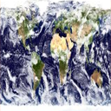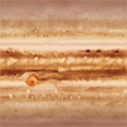

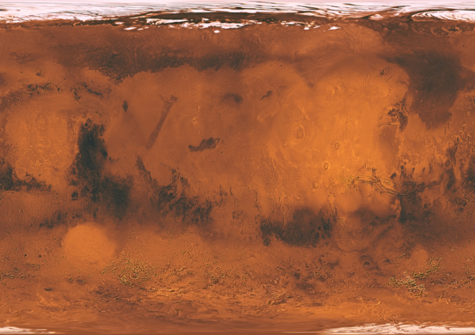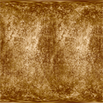

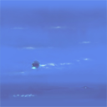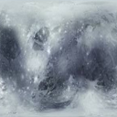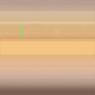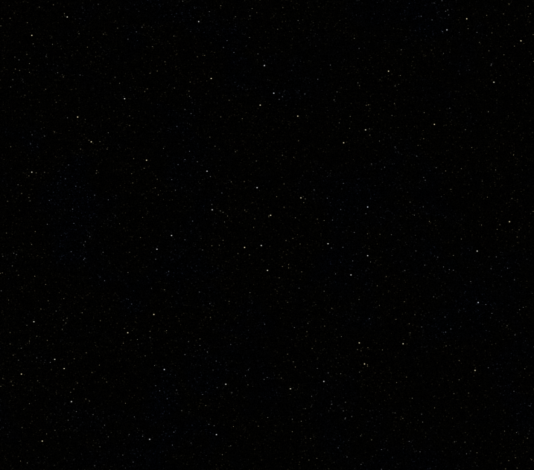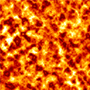

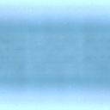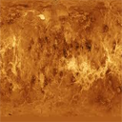

Logo
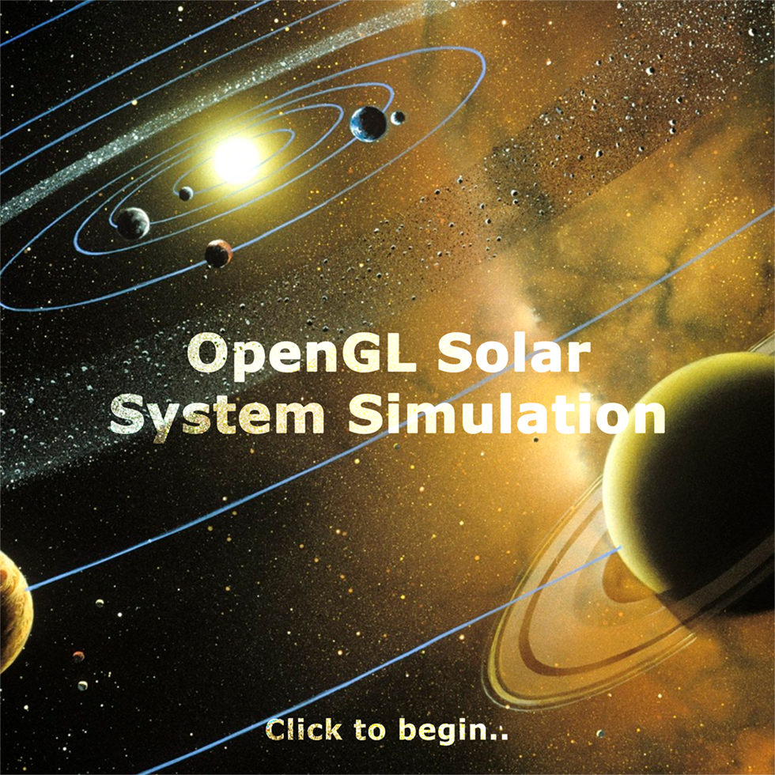

Result of the Project

